Part 1 regression model establishment
We will estimate change in SOC (ΔSOC) from crop C input in the US based on regression models. The regression models will be developed based on results from IPCC tier 2 steady state model. Thiagarajan et al. (2022) showed that ΔSOC have a strong relationship with site specific variables and C inputs. The regression can be expressed as follow:
$$∆SOC=intercept+a × Cumulative C input+b × MAP+c × Ini C stock$$
where
$∆SOC$ = the change in SOC (t C ha⁻¹)
Cumulative C input = the cumulative C input from crop in the estimated year (t C)
MAP = the mean annual precipitation (mm)
Ini C stock = initial C stock in the estimated area (t C ha⁻¹)

To establish the regression model, we will use published data to run the Tier 2 steady state model to obtain the ΔSOC and the use the three parameters to estimate the three coefficients (a, b, and c).

Q. I propose to have > 30 data across the U.S. and Canada

- Use the Canada’s inventory results (ecodistrict, texture..)
To build the regression to what the factors influencing SOC change.
Use this regression to predict SOC change in the US.
- If we need initial C stock in the US. We need help.
- 2006-2011 baseline => average C stock.
2012-2015
2016-2021 => estimate SOC for every year. => for SOC
2015-2016
2016-2017
2020-21

Part 2. Estimate C removal/emission factors across the U.S. and Canada
With the regression model, we can estimate annual ΔSOC for any region with their cumulative C inputs, MAP. And initial C stock. Remember that our goal is to provide average ΔSOC in 2016-2021 using the SOC from 2006-2011 as baseline.
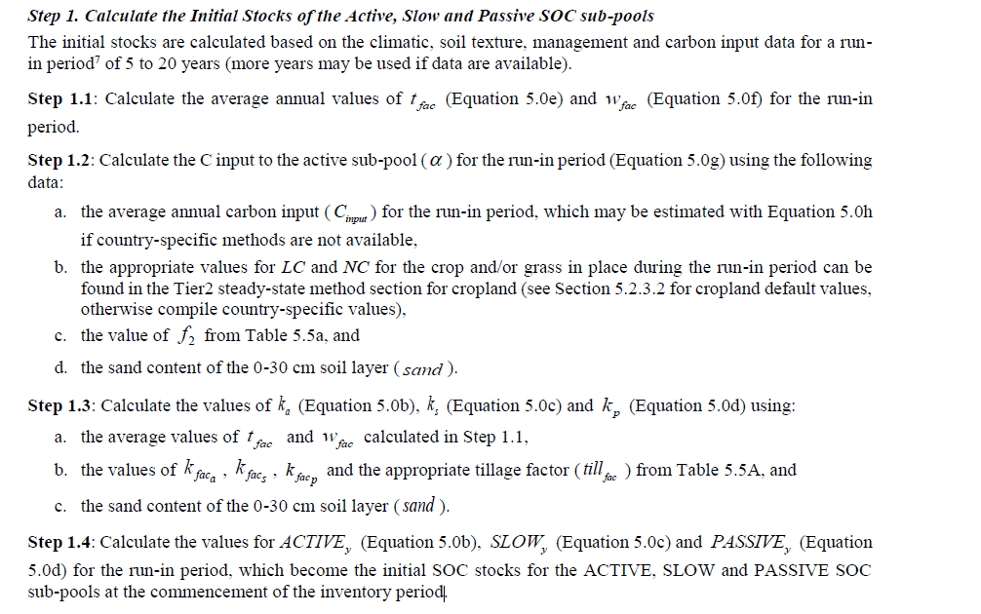
In this case, we will use this method in the IPCC 2019 Refinement to calculate the initial C stock (5 years, 2006-2011 will be used)

The results from the run-in period become the initial SOC stock for the active, slow, and passive SOC pools.

Q2. Since I need initial SOC for the regression model, does it mean I need run the steady state model for every regions?
Q3. Should I use this initial SOC values in the IPCC tier 2 model and use C input, and MAP in 2016 to calculate my SOC values?

Let’s assume ignoring specific crop now.
Data requirement
To run the steady state model, I’ll need
- Sand fraction of the soil (0-1)
- C input (we will need yield data and apply our method, i.e. Fan and Janzen, to estimate total C input)
- ligfrac and nfrac
For lignin and nitrogen content, values of 0.053 and 0.0069 will be used for wheat and durum wheat. Barley, corn (grain), rye (excluding spring rye), sorghum, and triticale will use 0.074 and 0.0068. For other crops including camelina, canola, field peas, and soybeans, we will consider other values.
- Till
We will need determine the tillage, a region (e.g. ecodistrict can have 50% tillage, 20% RT, 30% NT)
Weather data (1981-2010 or use the weather input for 2006-2021)
- Avg. monthly temperature
- Avg. monthly precipitation and potential evaporation
- Irrigationw9

Q3 We may not be able to have evapotranspiration data in the US

